Amy Scudder
802-654-2166
Box 3493 Saint Michael's College
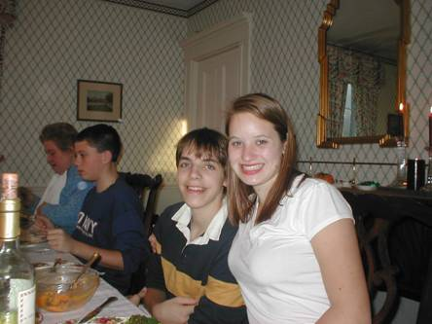

Jeff:

I remember when Mom was pregnant with you. I remember how happy I was that I was going to be a big sister. Over the years I've watched you struggle through many hardships, learn much about yourself and those that surround you. I have seen you push yourself to your limits time and time again...sometimes pushing just a little bit too far. Remember when you were about three years old and you asked Mom what would happen if you jumped off the porch stairs? She told you that you would probably break your leg. I guess that "probably" just isn't a certain enough answer for you, so you went ahead, jumped from a height so towering for one so short, landed, broke... and walked around for the next week telling everyone that you were "okay".
I think about you, and I think of the silly things that you've done which have influenced all of our lives. Who knows what "piggy bootins" are besides us? Who's the little brother that walks around the house with multicolor boxers on? Who's the little brother that almost "watered" Amelia when she was a puppy.
Whenever I come home from school now I'm always amazed by you. Mom and Dad will tell me what you're up to...but they always seem to forget what height you're up to. Jeff, you have definitely grown to your potential, and lucky for the rest of us you still have a lot of growing to do. I'm amazed by your strength and your courage. Your knowledge about video games and computers...but I'm especially floored by your constant desire to try new things and not resort yourself to living in a box.
There is an exciting world in front of you. A world in which you will carry with you your memories, your struggles, friendships and losses, things learnt, and things forgotten. Remember that you are a unique person..."Don't change for the world, but let the world change for you"

I love you

